

**American International University- Bangladesh**

**COE 3103: DATA COMMUNICATION**

**Final Lab Report 06**

**Spring 2021-2022**

**Section: I**

**Date: 05/04/2022**

**Submitted by, Group 03**

|  |  |
| --- | --- |
| Student Name | Student Id |
| Rahman, Sheikh Talha Jubayer | 19-41468-3 |
| Shifat, Mahabub Hasan | 19-41460-3 |
| Hasan, Sayeed | 19-41005-2 |
| Islam, Hasan Sanjry | 19-39589-1 |
| Durjoy, Md. Badrul Alam | 18-39248-3 |

**Solution of Performance Task**

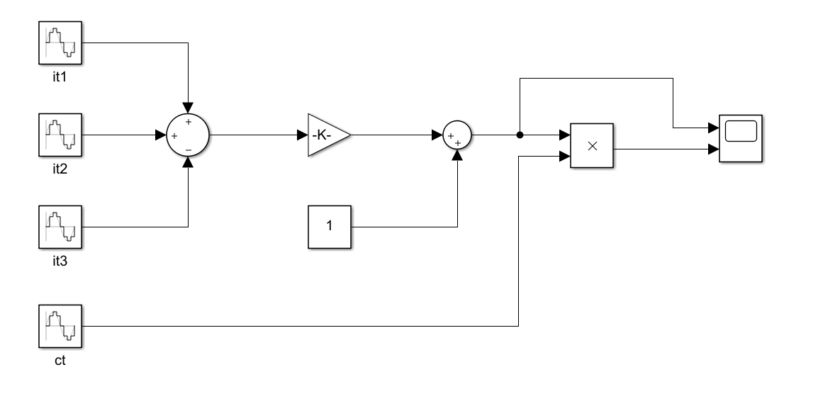

Figure 1: Modulation Block Diagram

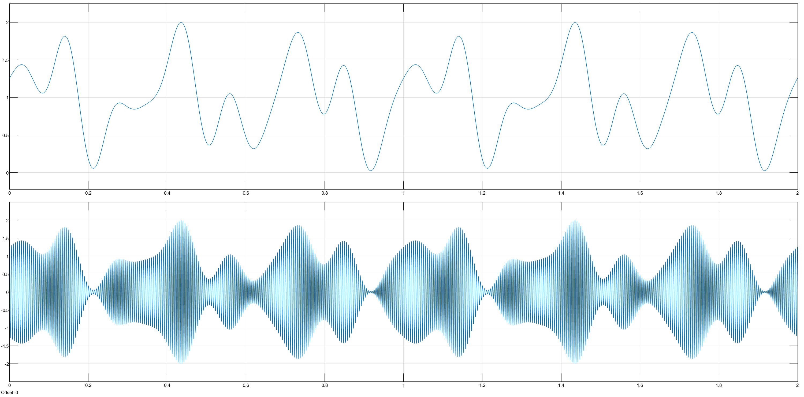

Figure 2: Modulation Output Scope [(mu*it)+1, mt]

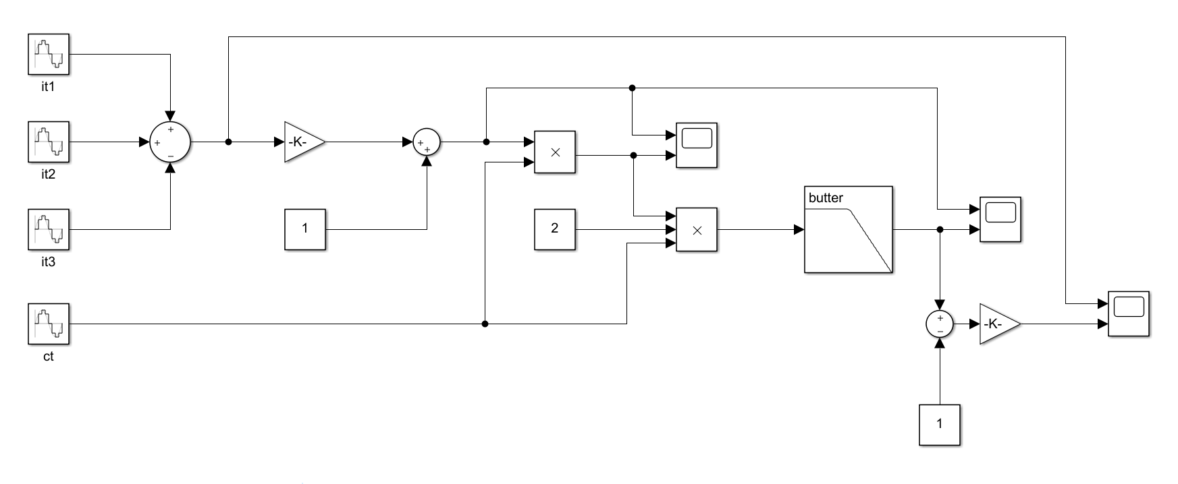

Figure 3: Full Block Diagram

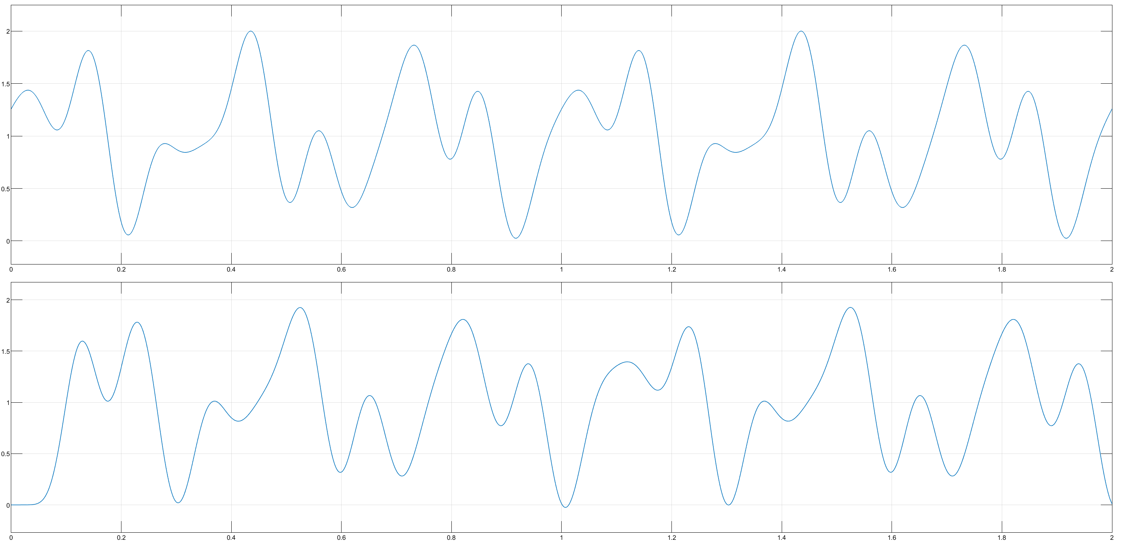

Figure 4: Demodulation Output Scope [(mu*it)+1, dmt]

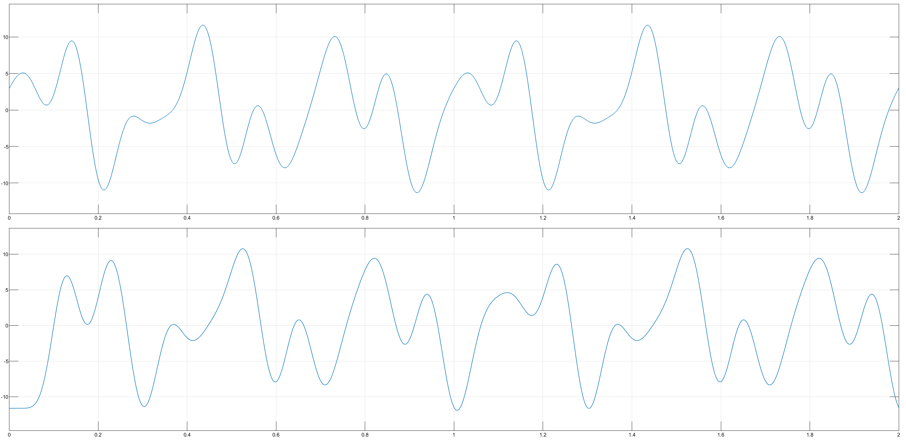

Figure 5: Original & Recovered Signal

Input Signals:

it1: Amplitude : 6

Frequency : 2*pi*3

Phase : 0

Sample Time: 1/20000

it2: Amplitude : 5

Frequency : 2*pi*7

Phase : pi/2

Sample Time: 1/20000

it3: Amplitude : 2

Frequency : 2*pi*10

Phase : pi/2

Sample Time: 1/2000

Carrier Signal:

ct: Amplitude : 1

Frequency : 2*pi*200

Phase : pi/2

Sample Time: 1/20000

Modulation:

1. First determine the max amplitude and link the input signal with gain of inverse max amplitude (mu = 1/max(it) = 0.0860), that gives a signal within amplitude range of -1 to 1.
2. Add that signal with constant 1, that gives a signal within amplitude range of 0 to 2.
3. Then product the signal with carrier signal and output is the modulated signal.

Demodulation:

1. Product the modulated signal with constant 2 and the carrier signal.
2. Then pass that signal in a lowpass filter with a passband edge frequency of higher frequency than the highest frequency component of the input signal. In this case the highest frequency component in input signal is 10Hz, so the frequency is 12Hz.
3. The output of the lowpass filter gives the demodulated signal.

Recovery Process:

1. Subtract constant 1 from the demodulated signal, that gives a signal within amplitude range of -1 to 1.
2. Then link the signal with gain of max amplitude of input signal (max(it) = 11.6223), that gives the recovered signal.
3. Compared the input signal and recovered signal using scope.

Conclusion:

In this experiment we have learnt Amplitude Modulation using Simulink block diagram. We used different components from the Simulink Library Browser to make a composite signal and perform the amplitude modulation to transmit the signal through a channel. Then we demodulated the modulated signal and recovered the signal in its original form. The recovered signal has a little phase and amplitude difference than the input signal but almost accurate.